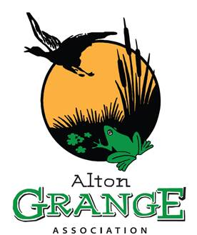

The Alton Grange Association presents two free events

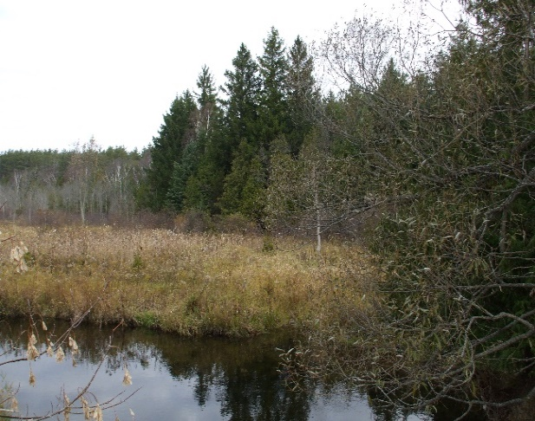
Critters in the Creek
From 11:30 AM to 1:30 PM
Have you ever wondered about what lives in the waters of Shaw's Creek? Join us and U of T scientists to learn more about the diverse world under the water and meet some of the insect inhabitants that call the creek home.
Rain boots are recommended.
Meet up at Shaw’s Creek Bridge (Station Street Entrance- first bridge) for this drop in event.

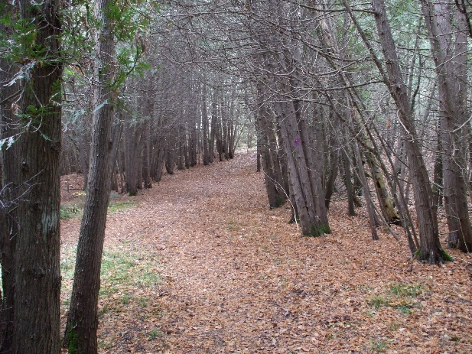
Getting to know The Grange One Step at a Time
Start time 1:00 PM
Join Loops & Lattes Hiking Guides author and Alton’s own Nicola Ross. She’ll lead this one-hour long hike through the Grange complementing the walk with some local stories about this wonderful property. She’ll tell you what she knows about the local flora and fauna, Shaw’s Creek, the Credit River and more. Bring water, good hiking or running shoes, and curiosity.
Meet up at the Alton Grange parking lot on Station Street at 1:00 PM for this 1-hour hike.
Parking available at the Station Street entrance to the Alton Grange.

